





AREA RESET,DATA,READONLY

EXPORT __Vectors

__Vectors

DCD 0X10001000

DCD Reset_Handler

ALIGN

AREA mycode,CODE,READONLY

ENTRY

EXPORT Reset_Handler

Reset_Handler

LDR R0,=0x01020304

LDR R1,=res

MOV R2,#0x0000000F

MOV R3,#0

MOV R4,#4

UP AND R5,r0,r2

LSL R2,#4

LSR R0,#4

ORR R3,r5

SUBS R4,#1

BNE UP

STR R3,[R1]

STOP

B STOP

AREA mydata,DATA,READWRITE

res DCD 0

END

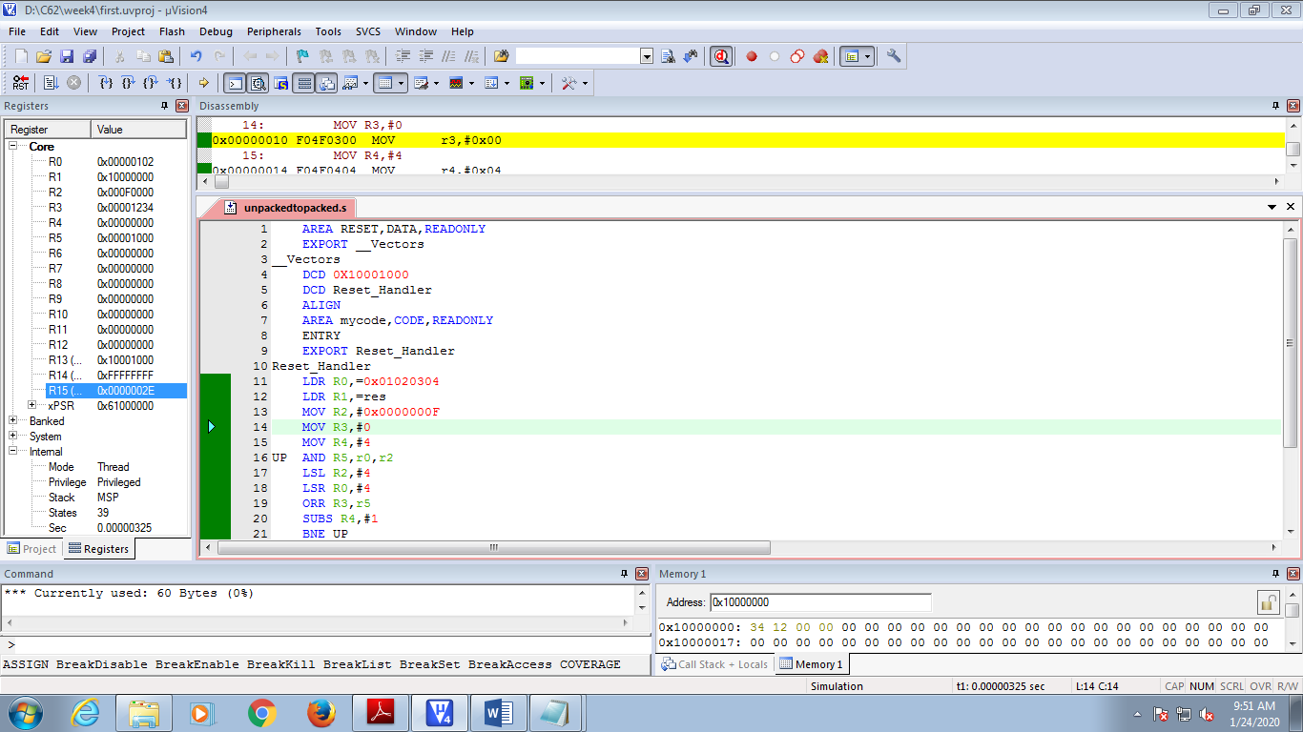



AREA RESET, DATA, READONLY

EXPORT __Vectors

__Vectors

DCD 0X10001000

DCD Reset_Handler

ALIGN

AREA mycode, CODE, READONLY

ENTRY

EXPORT Reset_Handler

Reset_Handler

LDR R6,=Res

MOV R2,#0

LDR R0,=VAL1

LDR R1,[R0]

up CMP R1,#0xA

BCC store

SUB R1,#0xA

ADD R2,#01

B up

store ADD R1,#0x30

STRB R1,[R6],#1

MOV R1,R2

MOV R2,#0

CMP R1,#0xA

BCS up

ADD R1,#0x30

STRB R1,[R6]

VAL1 DCD 0x0000000A

AREA data,DATA,READWRITE

Res DCD 0

END

